**Vision**

**Revision History**

|  |  |  |  |
| --- | --- | --- | --- |
| Version | Date | Description | Author |
| Inception draft | Sept. 7, 2014 | First draft. To be refined primarily during elaboration. | Kevin Niemiller |
|  |  |  |  |
|  |  |  |  |

**Introduction**

We envision a road activity web application that encompasses historical and real-time data, as well as a notification system. This system will be customizable to the user and give the user the ability analyze road activities in Ohio and be notified of road activities that might effect the user.

**Positioning**

***Problem Statement***

Traditional road activity, traffic applications, and map directions only provide real-time data. These systems also provide a way to enter an ending location so the system can provide a route home and show traffic on the current route. The problem with this is that most people already know the route they want to take which may not be the same as the map route. Users want a quick and reliable way to see road activity such as traffic and also a way to historically look at where the common problems are on the road so they which roads to avoid.

***Product Position Statement***

This system is for people who constantly travel on roads and highways that encounter traffic on a regular basis. These are people who might be travelling to and from work on a regular basis, or to and from school, etc. This system allows the user to configure the days, times, and roads that the user travels so the user can be notified when there is road activity such as traffic or an accident on the roads they use before they start using them. This system also allows a user to historically analyze the roads they most travel to see if there are common problems that are always happening on this road, which would allow the user to find an alternate path that might be less prone to road activity. These two main features, notification and historical data, are what separate this system from it’s competition such as Google Maps and Buckeye Traffic.

**Stakeholder Descriptions**

***Market Demographics***

This product is designed mostly for people between the ages of 23 and 65 who travel to and from work most days of the week. This demographic are the people who are affected the most by road activity such as broken down vehicles and accidents on their daily commute to and from work.

***Stakeholder (Non-User Summary)***

The main Non-User stakeholder is the Ohio Department of Transportation (ODOT). This stakeholder provides the real time road activity data that this web application will be using. ODOT’s goal is to provide Ohio travelers with up-to-date information on road conditions, traffic, construction, and other activity affecting roadways managed by ODOT.

***User Summary***

The user of this software is someone who travels on ODOT roads and highways and frequently runs into road activity such as disabled vehicles and accidents, which causes traffic. The user is someone who wants to avoid this traffic as much as he\she can.

***Key High-Level Goals and Problems of the Stakeholders***

|  |  |  |  |
| --- | --- | --- | --- |
| High-Level Goal | Priority | Problems and Concerns | Current Solutions |
| Historical Road Activity | High | Historical Data only goes back to 2012.  Road Activity is only for ODOT roads and highways so every road in Ohio is not covered. | Over time, more data will be stored to provide more of a historical window than just 2 years.  The ODOT roads and highways are the roads that usually have the most traffic and road activity so this is sufficient. |
| Notification System | High | Road Activity is only for ODOT roads and highways so every road in Ohio is not covered. | The ODOT roads and highways are the roads that usually have the most traffic and road activity so this is sufficient. |

*User-Level Goals*

The users (and external systems) need a system to fulfill these goals:

* User: signs up for an account, updates data, analyzes current and historical road activity, enters road(s) that he\she travels, updates account information, and updates user preferences.
* System: updates data, displays road activity, notifies user of new road activity that is occurring on their travelled roads.
* ODOT: provides the data for the road activity.

*User Environment*

The environment that the user will be using to succeed with their goal:

* User: computer and mobile phone.
* System: web application hosted in the cloud
* ODOT: xml file provided via URL

**Product Overview**

***Product Perspective***

This system will reside in the cloud on the Amazon Web Services platform. This web application will be accessible from any Internet capable device, such as a computer or mobile phone. It will provide services to users and use the ODOT artimis api as it’s data source.

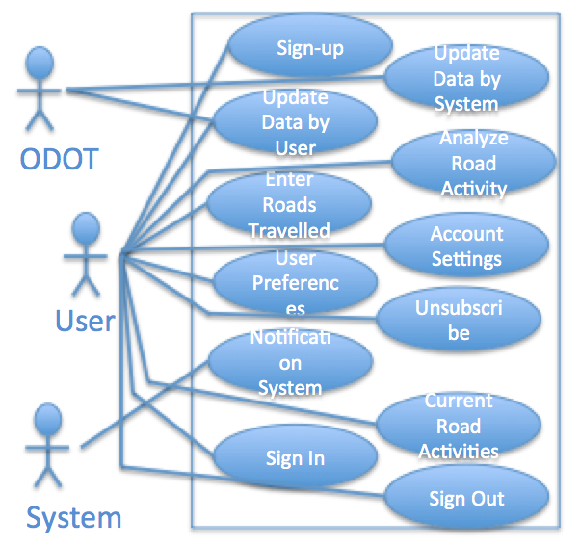

***Summary of Benefits***

|  |  |
| --- | --- |
| Supporting Feature | Stakeholder Benefit |
| Functionality, the system will provide historical and real-time road activity data as well as a notification system. | Automated, quick way to get road activity data to avoid traffic. |
| Automatic detection of failures and the ability to provide historical data if the ODOT website goes down | Continued services to user even when the ODOT website providing real-time data goes down. |
| Ability to update travelled roads and notification settings anytime | Flexible application to allow any road at anytime to be monitored. |
| Real-time data retrieval | Timely, accurate information to provide up-to-date data to the user. |

***Assumptions and Dependencies***

* It is assumed that ODOT will continue to maintain and update the data they provide that this web application relies on.
* This web application is dependent on the ODOT website to provide real-time data.

***Cost and Pricing***

* The web application uses a framework called Meteor, which does not have licensing fees or a cost to purchase the software to develop the product.
* The web application will be hosted on Amazon Web Services, which is free for the amount of data this web application will be storing.
* The web application will be free to users and will generate revenue with Google ads.

***Licensing and Installation***

This web application does not require any licensing and will not be licensed out to users since it is a free service. Installation is done on the cloud-based server, which allows this web application to be accessible from any web browser. No installation is required for the user.

**Summary of System Features**

* Historical road activity
* Notification System to notify user of road activity
* Real-time road activity data
* The ability to easily and quickly update notification and account settings

**Other Requirements and Constraints**

* User must have an email address
* User must have an internet capable device to access the web application
* System only works on ODOT roads and highways